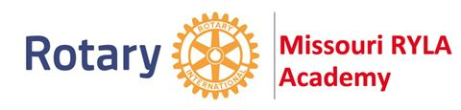
ROTARY CLUB of
ST. LOUIS
https://rotarystlouis.org http://www.missouriryla.com

Call for Nominations
Rotary Youth Leadership Academy (RYLA)

What is RYLA: Established in 1992, the Missouri RYLA Academy is a 4-day, 3-night training program for high school sophomores and juniors across Missouri who exhibit a desire for community service held at University of Central Missouri-Warrensburg.

Costs: The St. Louis Rotary Club will pay for all registration and RYLA participation costs which cover materials, food, and lodging at University of Central Missouri-Warrensburg. The students will be responsible for transportation to and from Central Missouri-Warrensburg.

Dates: There will be two Missouri RYLA Sessions for 2022, the first is June 26th-29th, and the second will be July 10th-13th.

Nomination Process: The St. Louis Rotary Club invites St. Louis high schools to nominate current freshmen, sophomores and juniors who have a demonstrated passion to community service by having students complete the following application form and submit a short essay to michele.goad@gmail.com and/or rosec904@gmail.com by Friday, April 1, 2022 @ 5 PM.
- A Rotary committee will review the essays and nomination materials and will select two RYLA participants as well as alternates should one of the participants be unable to attend.
Questions: Any follow-up questions or concerns should be sent to Rose @ rosec904@gmail.com 314-605-6333
https://rotarystlouis.org St. Louis Rotary Club 1/8/22

