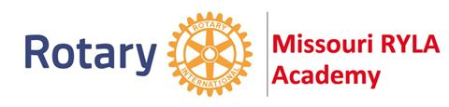
ROTARY CLUB of
ST. LOUIS
https://rotarystlouis.org http://www.missouriryla.com

ROTARY YOUTH LEADERSHIP ACADEMY CANDIDATE NOMINATION
University of Central Missouri; Warrensburg, Missouri - June 26-29, and July 10-13, 2022
Nominations must be returned to St Louis Rotary by Friday, April 1, 2022; 5:00 pm

Student Name: ______________ _______
first middle last Gender
Home Address:
street city, state zip
Student Phone #: Student E-mail:
(not a school e-mail)
Student's Grade 2021-22 School Year (circle one): 9 10 11
Preferred Academy Date: I __ June 26-29; or II ___ July 10-13;
and/or ___ I can attend either Academy
Parent/Guardian Name:
first middle last
Home Address (if
different from above):
street city, state zip
P/G Phone #: P/G E-mail:
Nominated Student and Parents/Guardians understand: Family is responsible for transport to and from the Academy; Students may NOT drive themselves.

Student Short Answer Questions (Please answer on a separate page):
- What community/school service activities have you participated in during this school year?
- What have you done to be a leader at your school/in your community?
- Why would you like to participate in the Missouri Rotary Youth Leadership Academy?

_______________________________/ /22 _________________________________/ /22
Nominated Student Signature & date Parent/Guardian Signature & date

Nominated by:

/ /22
Principal/Counselor Name & School, printed Principal/Counselor Signature & date

Submit Completed Nomination Application to:
michele.goad@gmail.com and/or rosec904@gmail.com

Please call Rose Cooper with any questions: 314-605-6333
Rotaryst.louis.org 1/8/22

