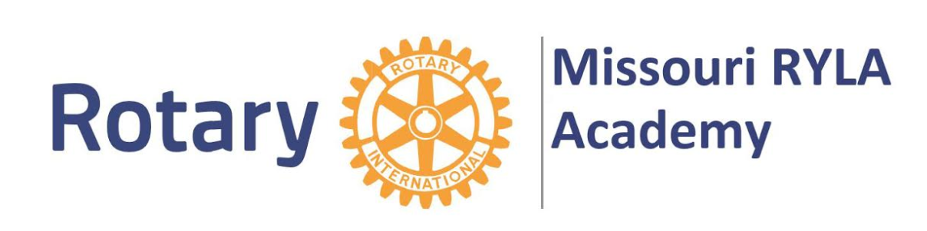
Rotary Club of St. Louis
Youth Leadership Award (RYLA) 2020 Application
Applications due Tuesday, March 31, 2020

Student Information:
Name: _
High School: Current Year in School:
E-mail (school): E-mail (personal):
Phone number:_________________________________________________________________

School Nominating Information:
Name: Position:
E-mail: Phone:

Student Short Answer Questions (please answer on a separate page):
What community/school service activities have you participated in during this school year?

What have you done to be a leader at your school/in your community?

Why would you like to participate in the Missouri Rotary Youth Leadership Academy?

Are you able to and commit to attend the Missouri Rotary Youth Leadership Award Academy on either June 28th –July 1st and/or July 12th-July 15th if selected for this award?

